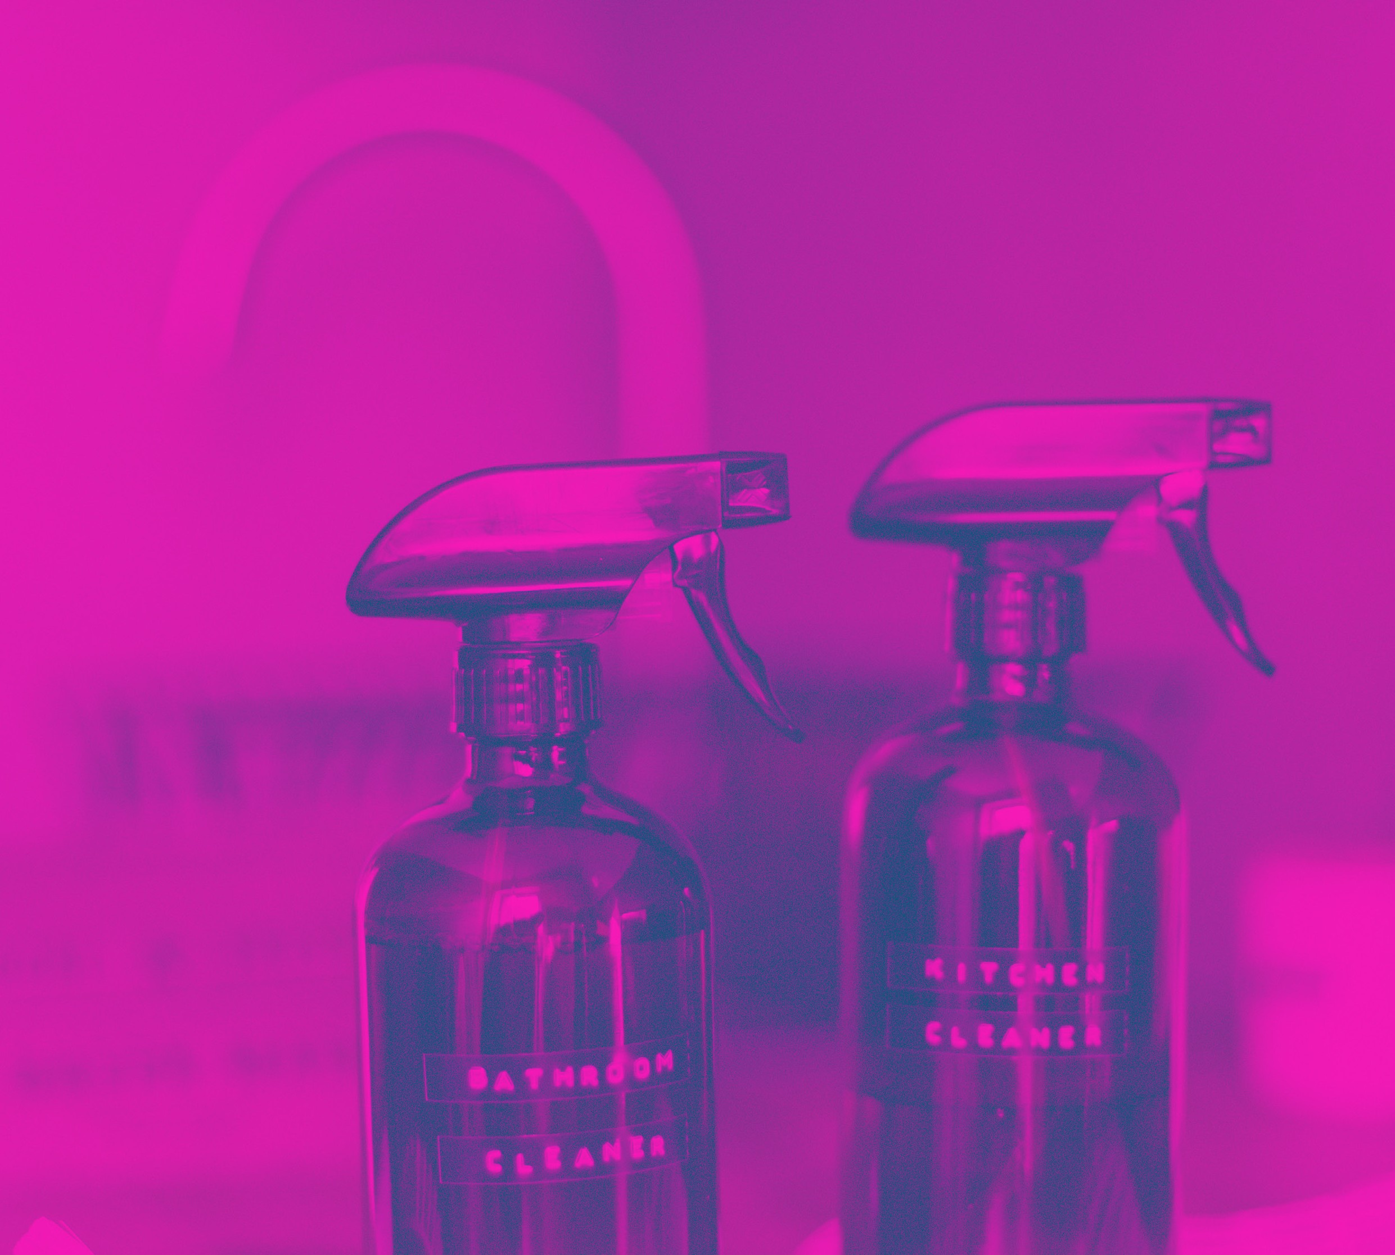ENDING YOUR

LEASE - CLEANING

Equipment & Cleaning Products you’ll need

Equipment
Dustpan & Broom Cloth wipes
Narrow vacuum nozzle (narrow enough for window tracks)
Screwdriver (thin enough to fit into window tracks)
Tooth Brush Scouring sponges Paper towels Clean towels Window squeegee Disposable gloves Mop & bucket Step ladder Vacuum cleaner Bucket
Broom
Pruning Scissors Tree Saw Outdoor broom Scrubbing brush Edge trimmer Lawn mower

Cleaning Products
Detergent Sugar soap
All-purpose spray and wipe Crème cleanser Disinfectant spray
Toilet bowl cleaner Oven cleaner Insect spray
Weed killer Driveway degreaser

3 weeks prior to end of your lease
A helpful checklist to help you get everything done in time to end your lease:
Give the legal notice to Marvel Realty as per your Residential Tenancy Agreement.
Contact Marvel Realty after you have given your notice to vacate to ensure it has been received and to confirm the end of lease/vacate date.
Cancel your utilities. Ensure you organize a final meter reading for your electricity and gas account.
Cancel your Telephone, Internet and Foxtel Accounts.
Arrange a professional carpet cleaner to have the carpets professionally cleaned a day before you return your keys to Marvel Realty. You will need to provide Marvel Realty with a receipt.
Lawns must be mowed within the last week of your tenancy. If you are not capable to mow the lawn yourself you will need to arrange a gardener to come in and do the lawns for you.
Arrange a pest control of the property if there are any pests or vermin present. A pest spray must be done if any type of pet approved or unapproved was kept on the premises and a receipt must be given to Marvel Realty.
If a pet of any type approved or unapproved was kept on the premises a full flea fumigation must be
done by a professional and a receipt must be given to Marvel Realty.

Interior of the home Exterior of the home
7 Days prior to the end of your lease

Remove and wash all light fittings, dry them and replace them.
Ensure any blown light bulbs are replaced. Wipe clean all ceiling fans.
Air conditioners must be cleaned and all filters need to be entirely cleaned for both split systems and ducted systems.
Remove the exhaust fans in the kitchen, clean the filter and re fit the cover once completed.
Remove the exhaust fans in the toilet, clean the filter and re fit the cover once completed.
Remove the exhaust fans in the bathroom, clean the filter and re fit the cover once completed.
All curtains must be washed throughout and placed back in their original position.
Vertical blinds must be wiped down and cleaned.
Vertical chains and cords must be intact and if they aren’t you must repair them.
Venetian blinds must be cleaned gently slat by slat.
Fly and insect spots must be removed from ceilings. Use sugar soap with warm water and a sponge to clean this. Test a small patch first to ensure it does not damage the paint work.
Scrub The driveway with a stiff broom with detergent and water to remove stains.
Use a gurney on the driveway if there are stubborn stains you cannot remove with detergent.
Mow the lawns.
Prune all trees and bushes to ensure they are tidy.
Remove all weeds around the property and spray them with weed killer.
Remove all rubbish from the yard.
Ensure all grass clippings are removed from the property.
Clean and sweep out your entire garage and ensure there are no cobwebs on ceilings and make sure all windows are cleaned entirely including the window tracks.

3 Days prior to the end of your lease

The property will need to be entirely empty with all belongings internally to be removed
Redirect all your mail to your new forwarding address
Brush down all cobwebs on the exterior of the house with a broom
Clean all window tracks throughout property by carefully running a screwdriver along the tracks to loosen the dirt

Vacuum all dirt with a narrow nozzle out of the window tracks
Wipe down the window track with a damp cloth or cleaning wipe using the screwdriver
Clean all windows and hose them down if necessary Clean all fly screens thoroughly

Bedrooms, living areas & hallways
2 Days prior to the end of your lease – last day of cleaning
Remove all cobwebs from ceilings.
Remove all marks from walls and ceilings. Use sugar soap.
Clean all light switches, power points and tv sockets.
Remove all personal hooks, pins, posters, blue tack and sticky tape from walls and clean the area.
Wipe down all skirting boards, architraves, doors and frames with a damp cloth.
Vacuum all wardrobes and cupboards and wash them with soapy water and dry.

Laundry

Remove all cobwebs from ceilings.
Remove all marks from walls and ceilings. Use sugar soap.
Clean all light switches, power points and tv sockets.
Remove all personal hooks, pins, posters, blue tack and sticky tape from walls and clean the area.
Wipe down all skirting boards, architraves, doors and frames with a damp cloth.
Vacuum all cupboards and wash them with soapy water and dry.
Remove all rust, calcium and soap scum from laundry tup with crème cleanser and a scouring sponge.
Wipe down all tap fittings and splash backs.
Scrub all marks from the floor with crème cleanser paying extra attention the where appliances were.

Toilets

Clean thoroughly and disinfect all parts of the toilet. This includes the fitting, pipe behind the toilet and the cistern.
Scrub the inside of the toilet with a toilet bowl cleanser and a toilet brush.
Clean all wall tiles with spray disinfectant and a cloth. Dry the wall once completed.

Kitchen

Remove all components of oven, range hood and stove (trays, racks, filters) including the knobs if they come off. Soak them in hot soapy water as long as possible (overnight if you can). Scrub with a firm scourer until everything is thoroughly clean.
Clean the oven thoroughly including all oven knobs and inside the oven glass. Re fit all oven components.
Wash the stove top with soapy water, gently scourer if necessary to remove all marks and food build up. Polish dry with a paper towel. Replace all knobs and burners.
Wipe and polish range hood including underneath the range hood. Clean the filter thoroughly and re fit it when completed.
Clean the dishwasher including filters and racks thoroughly they must all be free of food scraps.
Wipe down all kitchen cupboards doors internally and externally.
Wipe down all shelving inside the cupboards.
Wipe down above all cupboards and ensure no items are left behind.
Wipe down the sink. Clean the fridge space.
Clean the benchtop thoroughly.
NOTE: Please take care when cleaning appliances as any damage caused to appliances due to cleaning will need to be rectified and repaired at the tenant’s cost.

2 Days prior to the end of your lease – last day of cleaning

Bathrooms

Vacuum the entire bathroom to remove any hair and foreign material before you start cleaning.
Scrub the entire shower with a crème cleanser and a sourer sponge. Pay close attention to the corners, screen frame and top of the shower until there is no soap scum at all visible.
Ensure all mould stains are removed entirely if there is mould in the silicon arrange a handyman to rectify this.
Ensure the shower and bath tub drains are hair free.
Clean the exterior of the shower with glass cleaner and a paper towel.
Scrub the bath tub thoroughly with crème cleanser using a scouring sponge.
Wipe out the vanity and sink with a scourer if necessary. Ensure there is no mould or rust visible.
Ensure the vanity drain is hair free.
Polish the mirror and floor tiles with a glass cleaner and paper towel until it is streak free.

Floors throughout

Vacuum the entire house
Arrange for carpets to be professionally cleaned Sweep hard floors and mop
Sweep veranda’s & Patio

1 Day until you return your keys to the agency
Carpets should be professionally cleaned on this day.
Do a final walk through using your Marvel Realty final inspection checklist and ensure everything has been done.

Handy hints
Organize all tradespeople as early as possible to ensure they will be able to do work for you prior to you returning your keys to Marvel Realty.
If there are walls you may have damaged during your tenancy and they require painting contact the agent to confirm if the agent or landlord knows what colour paint was used originally to save you cost. If you paint the walls with mismatched paint you will be charged for the repainting of the entire wall no matter how small the patch job is.
All bathroom items including, toilet brush, air fresheners and towels must all be removed from the premises.
Using eucalyptus oil on a wash cycle in the dish washer will help to eliminate odours.
Scrub any food marks off the floor ready for a final clean.
If mould is present in your shower or bathtub you will need to use a mould remover and clean it with a tooth brush to get into the smaller areas.

Got questions? Contact us

Sydney office
2106, 31 Lasso Road, Gregory Hills NSW 2557

Newcastle/Maitland office
Suite 3, 12 Ken Tubman Drive, Maitland NSW 2320

Postal address
2106, 31 Lasso Road, Gregory Hills NSW 2557

Email us
pm@marvelrealty.com.au

Call us
02 9782 2202

marvelrealty.com.au

